**Task:** Fetch the links to all tennis matches for pinnacle.

**Steps:**

1. Go to <https://www.pinnacle.com/en/tennis/leagues/>, where all the tennis leagues are listed.
2. Add the href (link) of every tennis league to a list, the href is nested in the html.

Here are 2 examples:

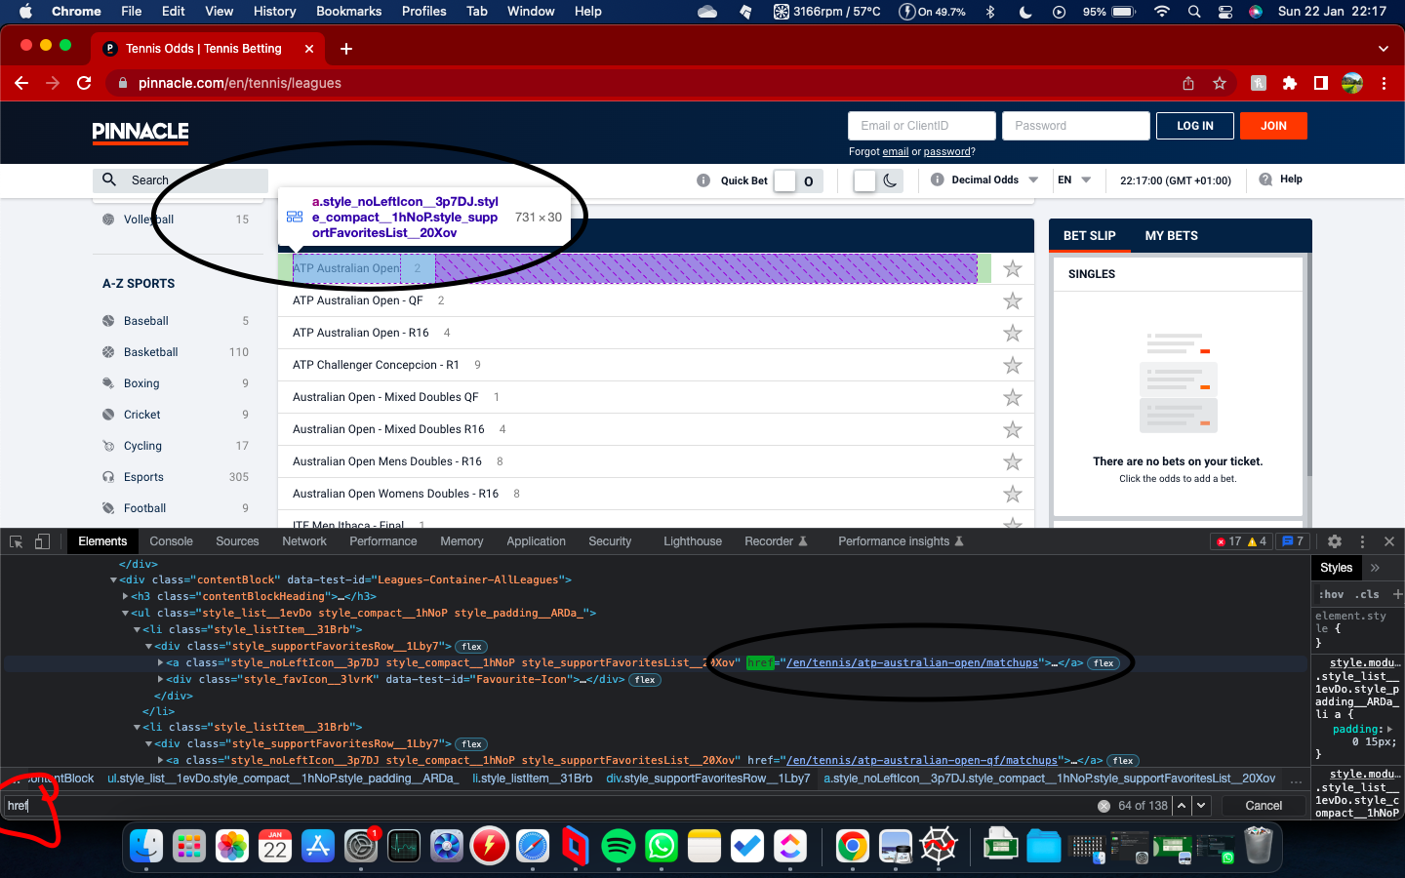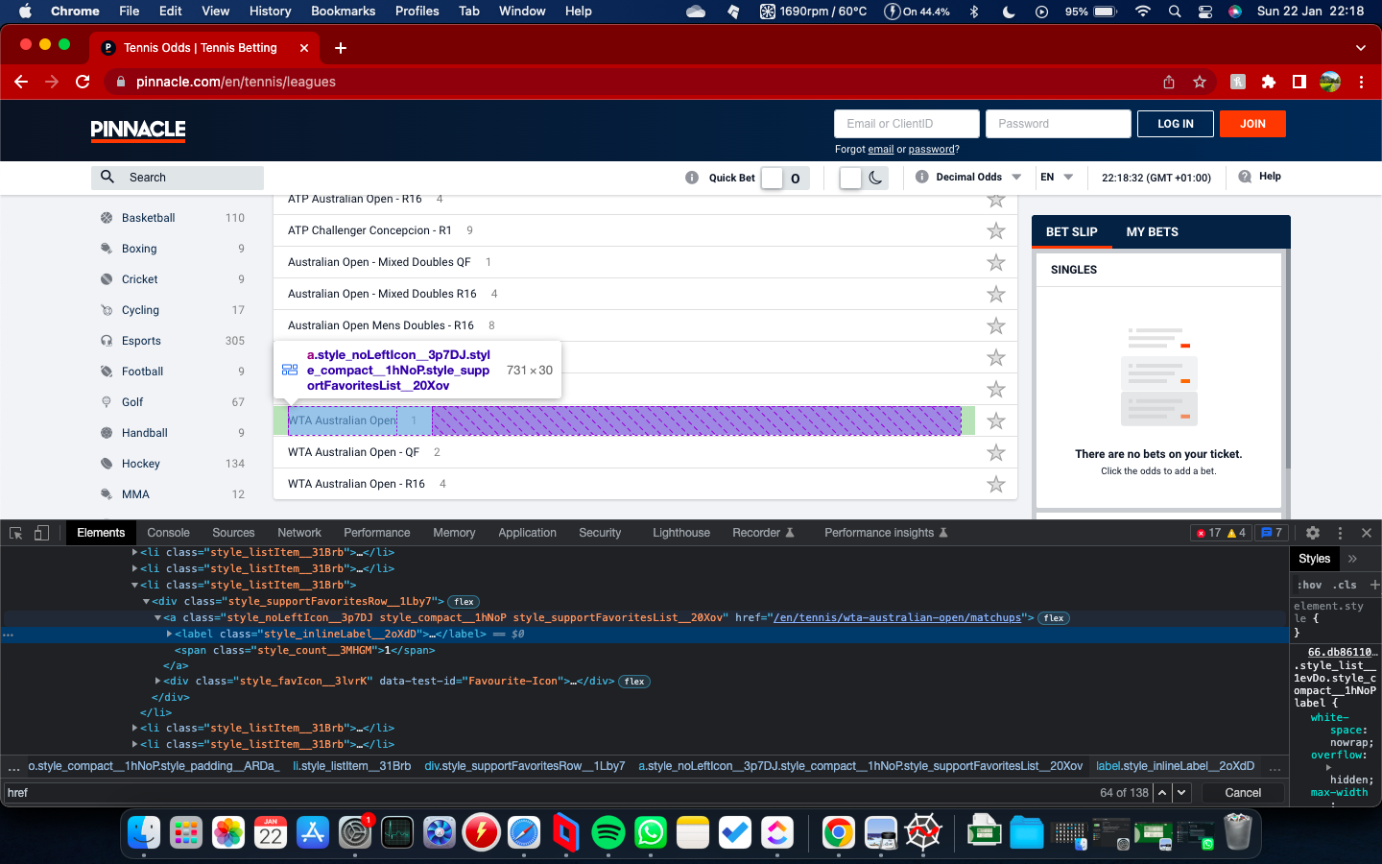

Notice: 1. the circled search term href 2. the circled match link and 3. the highlighted box in purple that is selected

1. Loop through the list that you just created and go to the page of every league.

Example, should look like this:

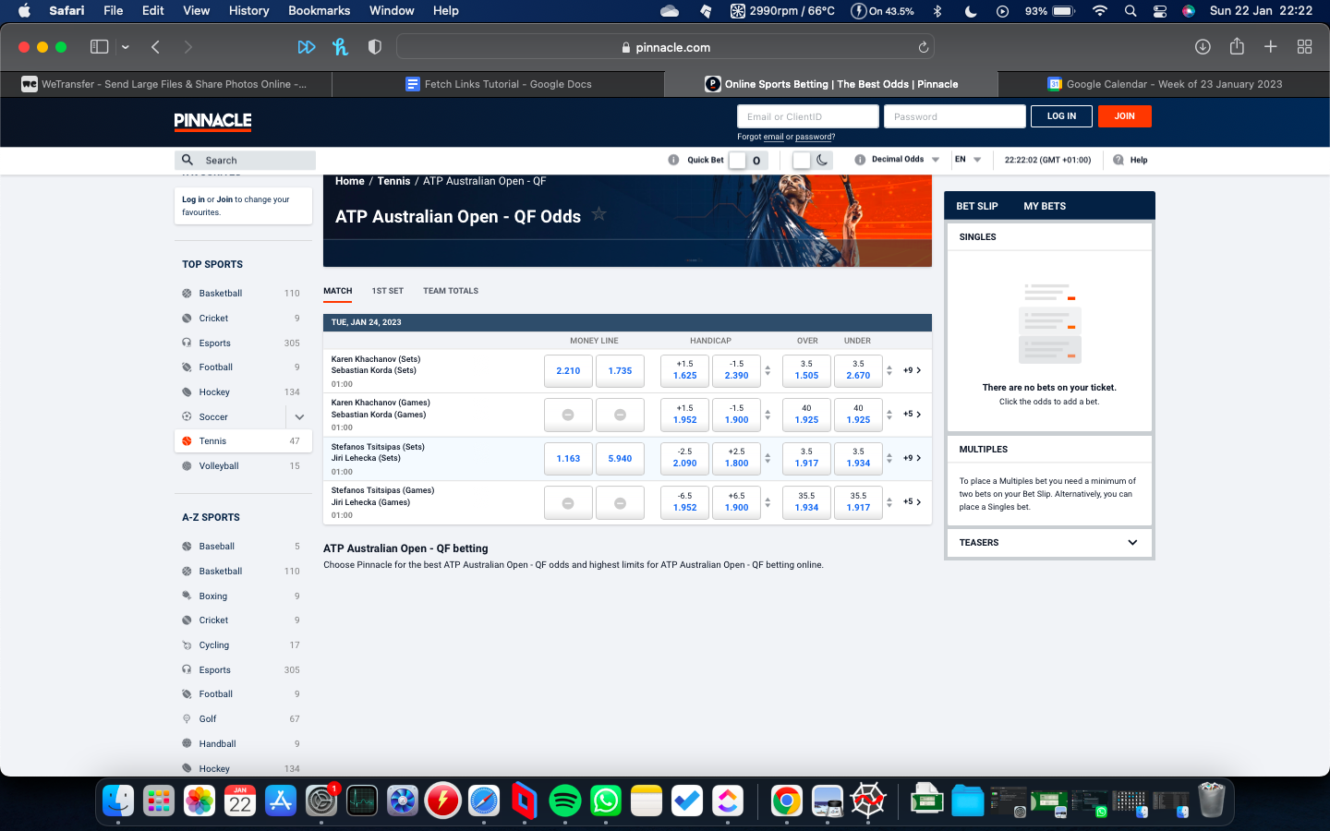

Notice all different matches from the according league. In this case ATP Australian Open. Clearly appended into a box.

List of links example:

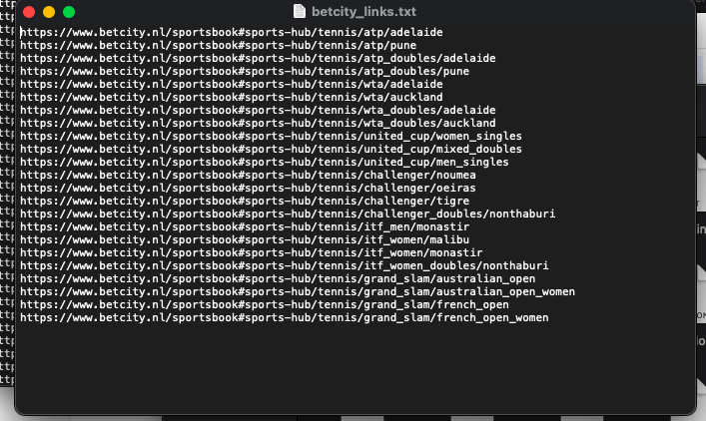

This is for betcity tennis matches.

1. For every league, save the href of every unique match in a list. The href is once again nested in the html. (Note: There are duplicate matches. Every match is once labeled with (Games) and once with (Sets). Only take the link to one of these.)

Example:

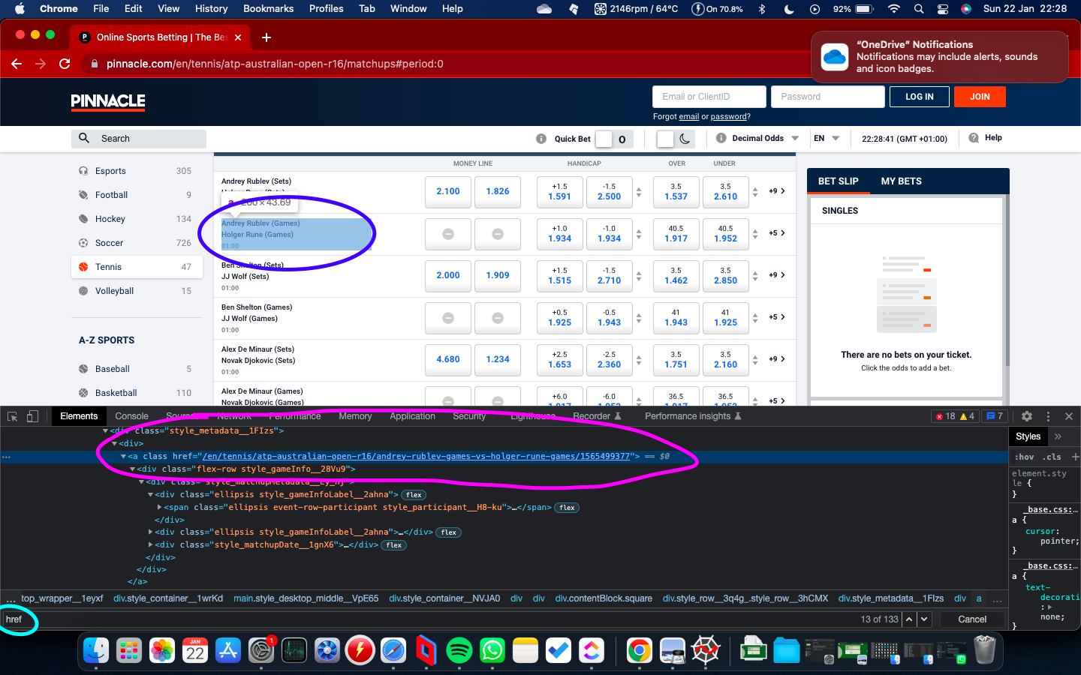  
Once again notice: 1. The match of the href in pink with according match link 2. The match that accompanies this link in blue. 3. the class href

Example:

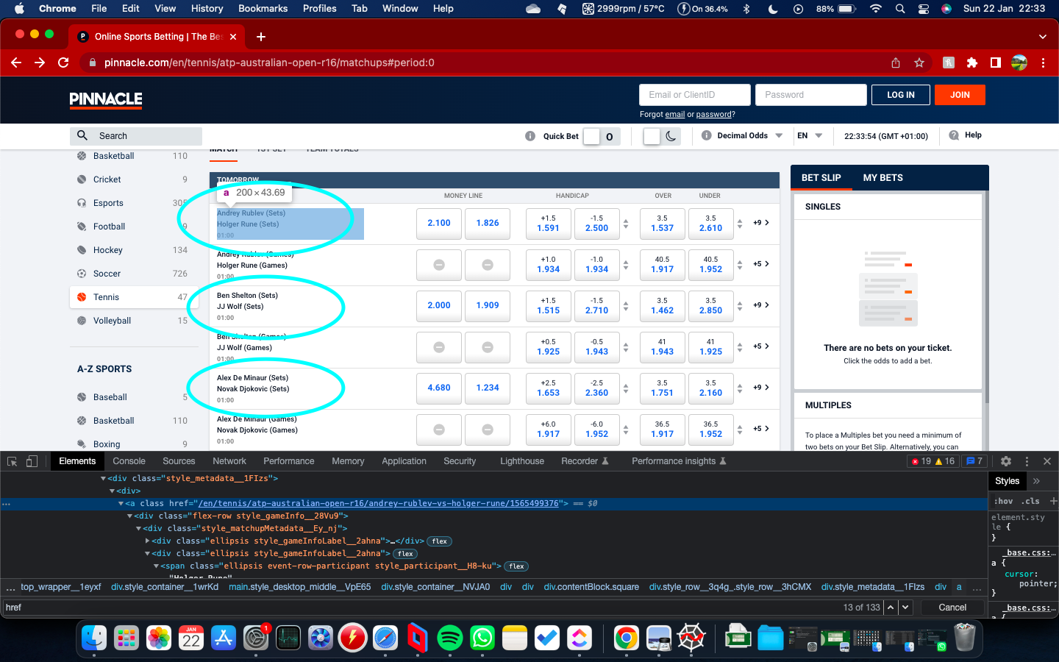

Notice only the matches with (sets) are circled. Only scrape these links not (sets) and (games)

1. You now have a list of all links to all tennis matches.

EXTRA EXPLANATION

In this **EMAIL on (22 jan 23:00) AMS TIME** there is a file **ATTACHED** **ZEBET.PY**

This is an updates version with the fetchlinks correctly working. Use this as a **REFERENCE**. It is **HIGHLY CONFIDENTIAL**.

This email contains fetching of the links on zebet. Here is an example of this loop. **FULL VERSION** in **ATTACHED** file in **EMAIL**.

